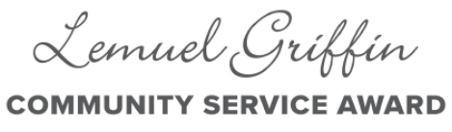
AWARD NOMINATION FORM

Please complete all fields and submit to GriffinAward@phoebehealth.com.
You can also print and mail the form to:

Lemuel Griffin Community Service Award
506 West 4th Ave
Albany, GA 31701

Nominations must be received by October 1, 2023

Who is nominating?
Name:
Email:
Phone:
(Note: we may contact you for additional information on your nominee)

Information for your nominee:
Nominee Name
Occupation / Employer
City of Residence
Contact Email
Contact Phone

How do you know the Nominee?
Describe your background or history with the Nominee

What characteristics, traits, or actions makes this person a great candidate for the Lemuel Griffin Award?

What single action or effort is the best example of the nominee’s Service mindset?
How have the Nominee’s actions impacted the community?
What results have they generated?

How does the nominee regularly demonstrate any of the key pillars of The Lemuel Griffin Award?

Thank you for you Nomination, and please note, we may contact you for more information and background on your Nominee!

